Objects of Silence: Colonial Memory and Museum Representation
By: Hilde Spaan
Universiteit van Amsterdam
14249251

Introduction
In 1946, my grandfather departed for Central Java, then part of the Dutch East Indies. He left Rotterdam for the former colony on the brink of an independence war. After the unilateral proclamation of the Republic of Indonesia by Sukarno and Hatta, a violent decolonization war erupted. What the Dutch state presented as “police actions” was in fact a bloody colonial conflict, marked by systematic atrocities and a desperate attempt to cling to one of its last colonies. Millions of Indonesians died of combat, hunger, and disease, while Moluccans among other ethnic groups were transported to the Netherlands under the promise of return, as their support for the KNIL (Royal Netherlands East Indies Army) made remaining in Indonesia unsafe (Naaijkens-Retel Helmrich, 2025).

Events from the colonial war were swept under the rug in the Netherlands; reports of extreme violence committed by Dutch soldiers were downplayed or concealed. After my grandfather returned, he too adhered to this silence. He did, however, bring back three kris daggers from Java, perhaps as mementos. A kris, known for its wavy, double-edged blade, functions as both weapon and spiritual object, symbolizing authority and protection. In Java, krises are worn openly on special occasions, such as weddings or the Javanese New Year (Naaijkens-Retel Helmrich, 2025). By hiding them in his cupboard, my grandfather overlooked their agency and significance.
In this essay, I analyze how the Wereldmuseum perpetuates a similar denial of agency and a blind spot regarding colonial violence. I use Donna Haraway’s concept of the gaze, which argues that objects in knowledge production are often reduced to passive matter, while their capacities and meanings are ignored (Haraway, 1988).

Signs in the Museum: Functional or Theatrical?
On the first floor of the Wereldmuseum, there is an exhibition on the colonial past of the Netherlands. Much historical information appears to be covered, yet crucial elements are missing. In one room, objects from Indonesia are displayed alongside photographs of Moluccans building new lives in the Netherlands. When examining the introductory sign representing their lives in the Netherlands, crucial information is missing. The colonial war that forced them to leave Indonesia is omitted, and it simply states they “came to the Netherlands.” This reflects Haraway’s (1988) idea of “situated knowledge”: historical narratives are partial, shaped by which stories are highlighted and which are silenced.

The museum states that “many felt compelled to leave,” implying choice rather than necessity. Moluccans who served in the KNIL were seen as traitors in Indonesia. They were temporarily transported to the Netherlands with the promise of return to the Republic of South Maluku (RMS), a promise never fulfilled. The museum describes their arrival as “traumatized and with few possessions,” understating the severe lack of resources and child deaths from hypothermia (Naaijkens-Retel Helmrich, 2025).

This framing not only erases historical reality but also denies the Moluccans their agency as active participants in their own story. Haraway’s concept of the gaze demonstrates that the people and objects are reduced to passive matter for the observer’s knowledge production (Haraway, 1988).

The Kris: Cultural Heritage or Private Property?
In the same area of the museum several krises are displayed, but the only information given is that they belonged to Duymaer van Twist, former Governor-General of the Dutch East Indies. Their spiritual significance is completely omitted. By presenting the object solely through the lens of colonial ownership, the museum denies the kris its agency, illustrating Haraway’s critique of objectification (Haraway, 1988).

Applying strong objectivity (Haraway, 1988) would involve co-curation with Indonesian communities, presenting the kris both as cultural heritage and a spiritual object. Alternative narratives and restitution dialogues could give the objects a voice, breaking the colonial perspective.

Unaware or in Denial?
Is this framing due to ignorance or unwillingness? The museum has both the knowledge and resources to tell a fuller story. Avoiding these deeper truths suggests a lack of will rather than a lack of knowledge. The tension between accessibility and confrontation is evident: Western visitors may not understand the kris’s significance, but that is no justification for erasing it.

The former "Tropenmuseum” approach, showing objects as exotic curiosities, still lingers. Counter-narratives-stories of resistance, trauma, and survival-are largely absent. The museum maintains a colonial gaze, a form of “weak objectivity” claiming neutrality while actually reinforcing existing power structures (Haraway, 1988). Standpoint epistemology, which builds knowledge from marginalized perspectives, is not applied.

Conclusion
The case of the kris and the presentation of Indonesia and the Moluccan diaspora in the Wereldmuseum illustrates how the museum continues to operate within a colonial framework. Objects are framed through Dutch ownership, histories of violence are minimized, and indigenous perspectives are absent. This reflects not ignorance but institutional unwillingness, reinforced by the tension between accessibility and uncomfortable truths.

The story of my grandfather, who returned from Java after the violent decolonization war with three krises and hid them, mirrors the museum’s approach: both deny the objects’ cultural and spiritual significance. Just as he carried the weight of war and silence, the museum reduces meaningful entities-heirlooms or artifacts-to passive objects. The krises thus link personal and institutional memory, highlighting the need to recognize and honor both the objects’ significance and the histories of violence they embody.

Applying Haraway’s concept of the gaze demonstrates that the museum reduces objects to passive matter and denies their agency. Collaborating with source communities, co-curation, restitution dialogues, and inclusion of multiple narratives could establish a stronger epistemological and ethical foundation. Strong objectivity could involve, for example, consulting Indonesian and Moluccan communities in exhibition design, explicitly acknowledging traumatic histories, and foregrounding Dutch responsibility for colonial violence.

Only through such changes can the museum honor both historical reality and the cultural significance of objects such as the kris. Until this happens, the Wereldmuseum remains part of a system that erases and marginalizes the voices and agency of the very objects and communities it seeks to display.

References

Haraway, D. (1988). Situated Knowledges: The Science Question in Feminism and the Privilege of Partial Perspective. Feminist Studies, 14(3), 575–599.

Naaijkens-Retel Helmrich, H. (Director). (2025). Anak Indië [Documentary]. Scarabeefilms. Viewed on June 17th 2025.

Annex

1: The introductory text about the photos of Moluccans in the Netherlands and objects from Indonesia
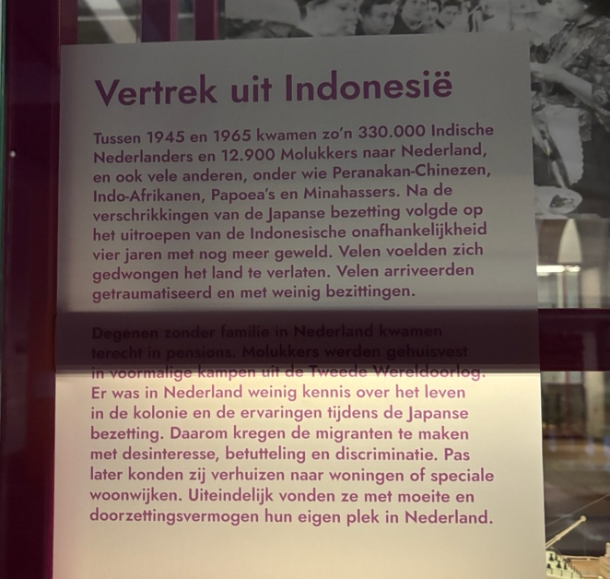

2: The text panel about the krises
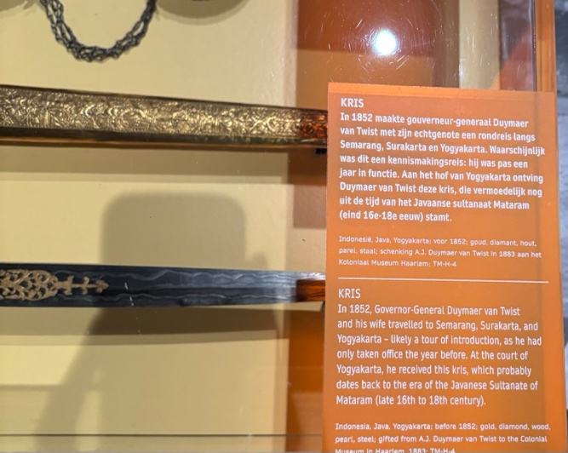

3: The krises
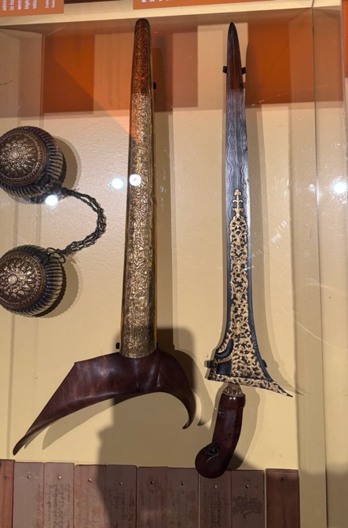

4: Use of ChatGPT
- Spelling check

